Project 2 consists of two C++ Programs:

Concepts tested by programs in this project:

- To work with cout object (to display output/prompt/message)
- To work with cin object (to obtain input from user, i.e., ask user to enter the number of tickets sold for each category)
- To work with mathematical expressions
- To work with characters and string objects
- To work with some Mathematical Library Functions

Program 1: Employee Pay

Program Specifications
A small company has hired you to write a program for three of their employees. The program should take each employees’ name, hourly pay rate, and the number of hours worked. The program should calculate the amount of money each employee made, as well as the average hourly pay rate and the average amount of money made. Format the dollar amount in fixed-point notation, with two decimal places of precision, and be sure the decimal point is always displayed.

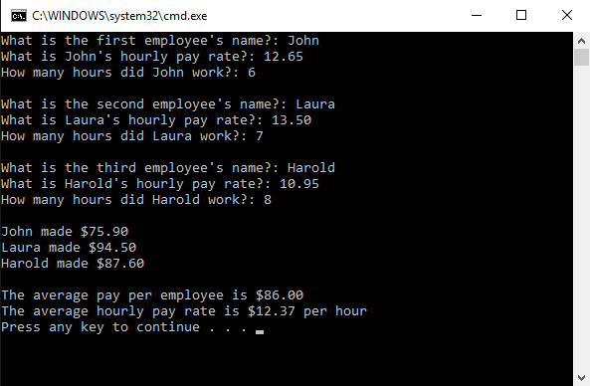

NOTE: “Press any key to continue…” is a message displayed by Visual Studio.

Program 2: Ice Cream Scoops

Program specification

Harold’s Cone Castle needs a program to calculate the number of scoops of ice cream that can fit into a cone of any size. The program should perform the following steps:
A) Ask the user for the radius of the cone’s base in inches
B) Ask the user for the height of the cone in inches
C) Calculate the number of scoops that can be put into the cone
D) Display a message telling the number of scoops

To calculate the number of scoops that can be put into a cone, you must know the following facts:
- Each scoop of ice cream should have a volume of 5 cubic inches
- To calculate the number of scoops, divide the volume of the cone by 5.
- The volume of the cone is calculated with this formula:
Volume = πr²h / 3

Note: π is the Greek letter pi. 3.15159 should be used as its value. The variable r is the radius of the cone’s base, and the variable h is the height of the cone.

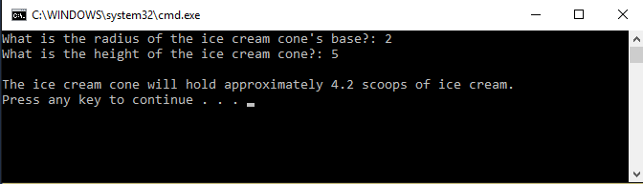

NOTE: “Press any key to continue…” is a message displayed by Visual Studio.

Program 1 and Program 2 Submission requirements:

Deliverables (items to submit):
- Two (2) C++ files, one for each program. Name the first one FirstInitialLastName_Pr2_1.cpp and the second one FirstInitialLastName_Pr2_2.cpp
- The MOSS zip file. Name the file FirstInitialLastName_Project2_MOSS.zip. This is a compressed (zipped) file containing the two .cpp files mentioned above
- A Word document that includes a screen snapshot of output, a test plan and a flowchart diagram or algorithm for each program
Note: the MOSS zip file should contain only the following two source files and NOTHING else:
FirstInitialLastName_Pr2_1.cpp
FirstInitialLastName_Pr2_2.cpp

 Your completed assignment should be submitted to the Blackboard ->Course Content-> Module xx->"Project 2" assignment area no later than the due date.
You should include one block comment at the top of each program containing the course name, the project number, your name, the date and platform/compiler that you used to develop the project as listed below
/*
* Class: CMSC140
* Instructor:
* Description: (Give a brief description for each Program)
* Due: MM/DD/YYYY
* I pledge that I have completed the programming assignment independently.
I have not copied the code from a student or any source.
I have not given my code to any student.
Print your Name here: __________
*/

Notes:
- If program does not compile, project will get grade “0”. Contact your instructor prior to the project submission due date, if you have compilation issues.
- Proper naming conventions: All constants, except 0 and 1, should be named. Constant names should be all upper-case, variable names should begin in lower case, but subsequent words should be in title case. Variable and method names should be descriptive of the role of the variable or method. Single letter names should be avoided.
- Documentation: The documentation requirement for all programming projects is one block comment at the top of the program containing the course name, the project number, your name, the date and platform/compiler that you used to develop the project. If you use any code or specific algorithms that you did not create, a reference to its source should be made in the appropriate comment block. Additional comments should be provided as necessary to clarify the program.
Indentation: It must be consistent throughout the program and must reflect the control structure

Test Plan Template
Input | Actual input | Expected Output | Actual Output | Did Test Pass?

Example: Test Plan Program 1
Input | Actual input | Expected Output | Actual Output | Did Test Pass?
Name of first employee | John | Display a message that tells how much each of the employees made, the average hourly pay rate and average amount of money made | Employee Pay:  $75.90  $94.50  $87.60 | Y
Hourly pay rate of first employee | 12.65 |  | Employee Pay:  $75.90  $94.50  $87.60 | Y
Hours worked by first employee | 6 |  | Employee Pay:  $75.90  $94.50  $87.60 | Y
Name of second employee | Laura |  | Average money made:  $86.00 | Y
Hourly pay rate of second employee | 13.50 |  | Average money made:  $86.00 | Y
Hours worked by second employee | 7 |  | Average money made:  $86.00 | Y
Name of third employee | Harold |  | Average rate:  $12.37 | Y
Hourly pay rate of third employee | 10.95 |  | Average rate:  $12.37 | Y
Hours worked by third employee | 8 |  | Average rate:  $12.37 | Y

Example: Test Plan Program 2

Input | Actual input | Expected Output | Actual output | Did test Pass?
Ask the user for the radius of the ice cream cone in inches. | 2 | Display a message telling the number of scoops. | 4.2 | Y
Ask the user for the height of the ice cream cone in inches | 5 | Display a message telling the number of scoops. | 4.2 | Y

